Practice to Patient Newsletter or email content

Introducing Insera™ S-R.
Easy to hear. Smile from ear to ear.
Smile hearing aids enhance the sounds you want to hear and minimize the ones you don’t. They automatically adjust to your environment, optimizing sound settings so you can stay engaged in the conversation with less effort in the moment and less fatigue at the end of the day.¹
Whether you’re catching up with friends in a bustling café or chatting quietly at home, you can enjoy quiet moments, big laughs, and engaging stories.
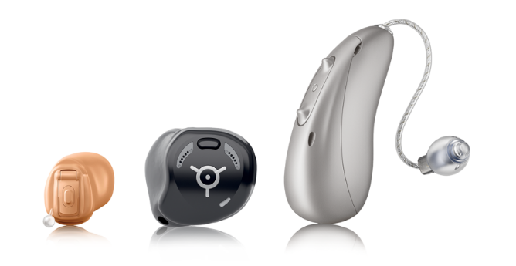

Meet Moxi S-R. A sleek, rechargeable style that fits behind your ear, built for all day wear and effortless connection—at home, on the go, or wherever life takes you.

Introducing Insera S-R
A discreet, custom, in-the-ear style that’s made just for you, with rechargeable power and reliable connectivity.
Prefer traditional batteries?
A non-wireless option, Insera™ 10 NW O offers a comfortable, custom fit with reliable performance.

Effortless connectivity.
Insera S-R hearing aids offer easy, reliable universal connectivity² with instant compatibility for hands-free calls and smooth media streaming across all your Bluetooth®- enabled devices.
Enjoy fast and seamless switching between in-person conversations, phone calls, and streamed media—plus powerful wireless transmission that provides the freedom to walk away from your phone while staying connected and engaged.

1 Reference: Latzel, M., Heeren, J., and Lesimple, C. (2024).
2 Not available for the Insera 10 NW O.
The Bluetooth® word mark and logos are registered trademarks owned by
Bluetooth SIG, Inc., and any use of such marks by Sonova AG is under license.

