**Unitron Moxi SmileTM Social Media Posts**

**Post 1:**



**Copy:** Your hearing experience is personal—your hearing solution should be too.

The new **Moxi™ S-R** hearing aids deliver:

* **Brilliant sound performance** for an enjoyable listening experience
* **Reliable universal connectivity** to stay in sync with your devices
* **All day comfort** designed to fit effortlessly and discreetly into your life.

Experience hearing that fits your life. **Call us at XXX-XXX-XXX today to learn more!**

**Post 2:**



**Copy:** Your hearing. Your way.

Experience brilliant sound performance, seamless connectivity, and all-day comfort with the new Moxi™ S-R hearing aids. Designed to fit your world, so you can stay effortlessly connected to what matters most.

Call us at XXX-XXX-XXX today to learn more!

**Post 3:**

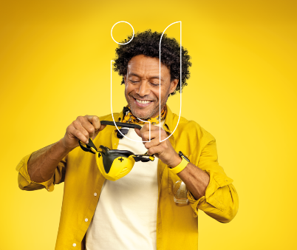

**Copy:** From your morning coffee to your evening walk, Moxi™ Smile hearing aids are built for all the moments that matter. With a comfortable, secure fit and a discreet look, they support you wherever life takes you—bringing joy, ease, and confidence to every day.

Let your hearing keep up with your life. Call us today to start your journey to better hearing. XXX-XXX-XXXX.

**Post 4:**



**Copy:** Life is full of sounds that make each moment meaningful—and you deserve to hear them in vibrant detail. Moxi™ Smile hearing aids are designed for all-day comfort and confident wear, rain or shine. With a sleek, discreet design and water-resistant durability, they fit effortlessly into your life so you can enjoy every moment, from morning routines to evening conversations.

Smile from ear to ear with Moxi™ Smile. Call us today at XXX-XXX-XXXX to schedule your hearing consultation.

**Post 5:**

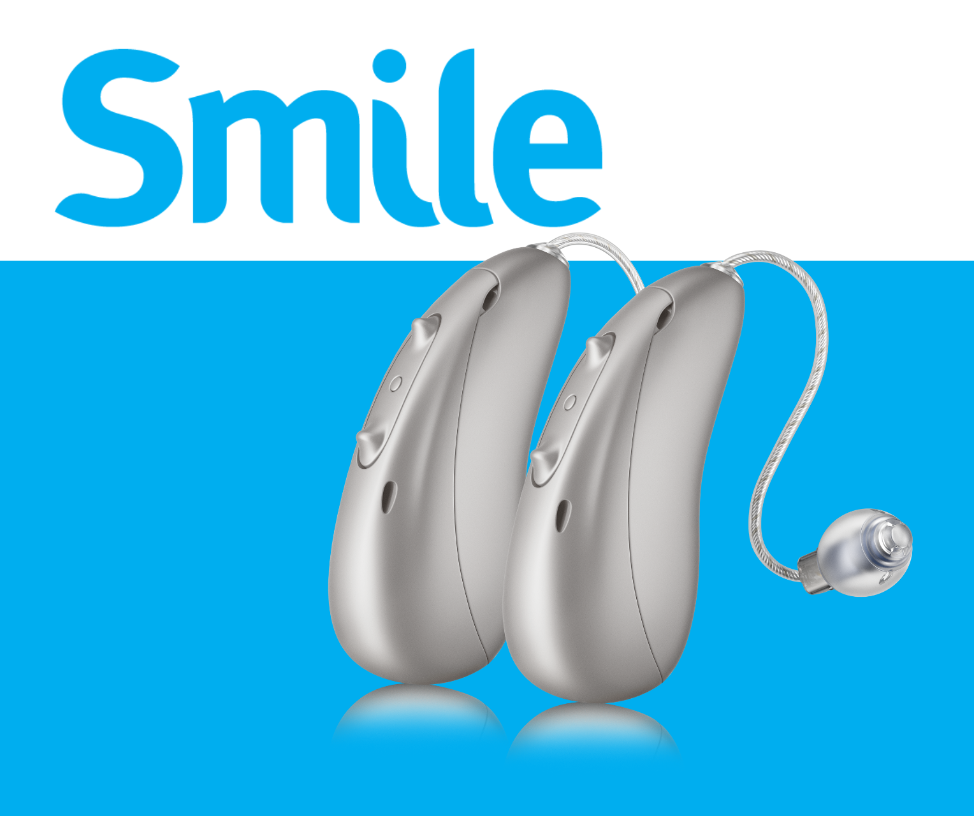

**Copy:** Moxi™ Smile hearing aids are built for real life—sleek, water-resistant, and designed for all-day comfort. From the moment you put them on, they fit naturally into your day, keeping you connected and confident no matter where life takes you.

Discreet design. Reliable performance. Effortless wear.

Call us today to find out if Moxi™ Smile is right for you.