A Sonova brand

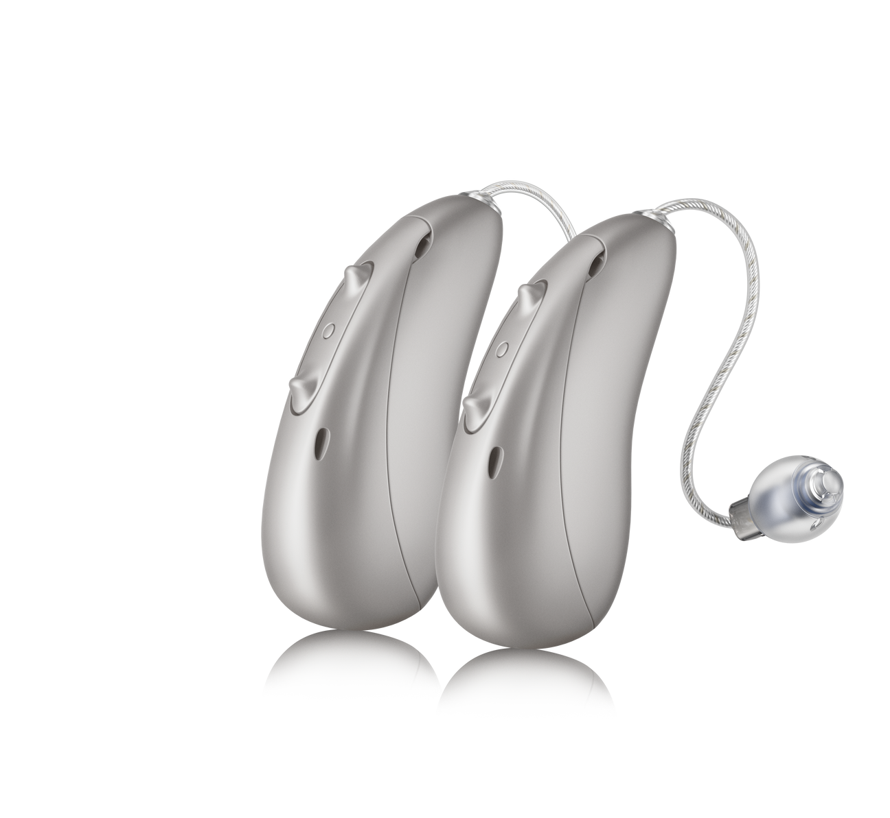

Easy to hear

041-2809-03/A/2025-03/hc ©2025 Sonova AG, or its affiliates. All rights reserved.

A brilliant listening experience that elevates the sounds you want to hear.

Ask us about Smile hearing aids.