Unitron Vivante + TV Connector Booster Campaign
B2B2C Social Media Posts

POST 1: Offer, version 1

Social Media Platform | Post caption | Image
LinkedIn | We’re giving you even more reasons to cheer with this special offer: Buy 2 Vivante hearing aids by July 31, and receive a free PartnerMic or TV Connector. Book an appointment now: [URL] | 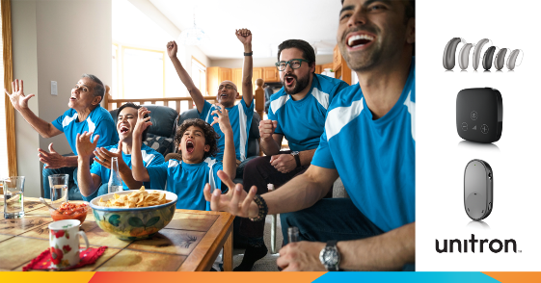  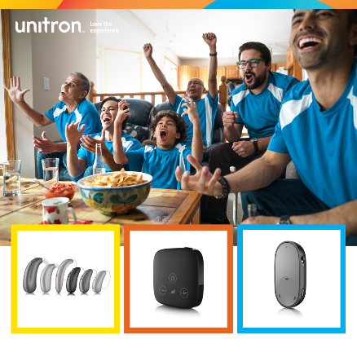
Facebook | Get into the games! When you buy 2 Vivante hearing aids by July 31, get a free PartnerMic or TV Connector. Book an appointment [URL]
Instagram | We’re giving you even more reasons to cheer with this special offer: Buy 2 Vivante hearing aids by July 31, and receive a free Partnernic or TV Connector. Contact us to learn more.

POST 2: Offer, version 2

Social Media Platform | Post caption | Image
LinkedIn | As the summer games heat up, now is the perfect time to introduce the sports enthusiasts to our PartnerMic or TV Connector – yours free when you buy 2 Vivante hearing aids by July 31. Book your appointment at [URL]. | 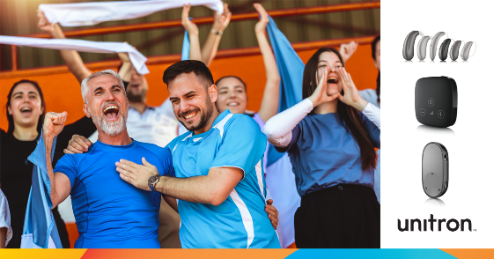  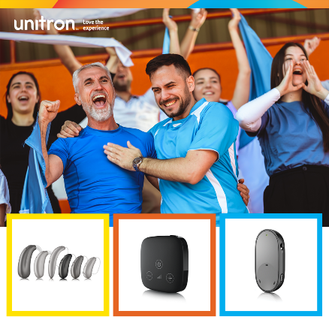
Facebook | Get the front-row feel at home with a free PartnerMic or TV Connector when you buy 2 Vivante hearing aids by July 31. Book an appointment at [URL]
Instagram | Hey sports fans, now you can experience the front-row feel at home with a free PartnerMic or TV Connector when you buy 2 Vivante hearing aids by July 31. Contact us to learn more.

POST 3: TV Connector

Social Media Platform | Post caption | Image
LinkedIn | Don’t just watch the games, experience them. When you purchase a pair of Vivante hearing aids, you will receive a free PartnerMic or TV Connector. Contact us to learn more: [URL] | 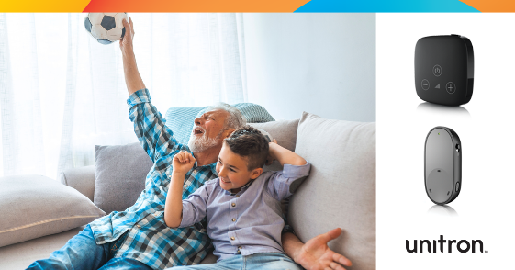  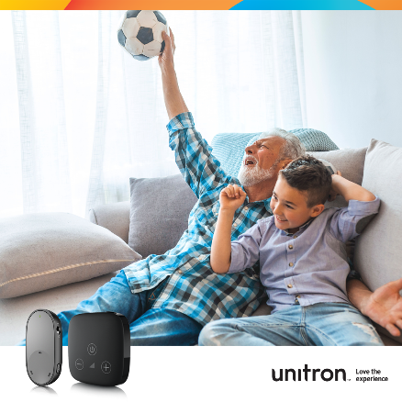
Facebook | Enjoy all your favorite sports action streaming directly to your hearing aids. Now until July 31, when you purchase a set of Vivante hearing aids, you get a free PartnerMic or TV Connector. Book an appointment to learn more: [URL]
Instagram | Immerse yourself in the action with Vivante hearing aids. Now until July 31, when you purchase a set of Vivante hearing aids, you get a free PartnerMic or TV Connector. Contact us to learn more.

POST 4: Vivante

Social Media Platform | Post caption | Image
LinkedIn | From the roar of the crowd to the hush of suspense, Vivante hearing aids automatically adapt to deliver a sports viewing experience we think you’ll love! Now until July 31, when you purchase a set of Vivante hearing aids, you get a free PartnerMic or TV Connector. Book a consultation to learn more: [URL] | 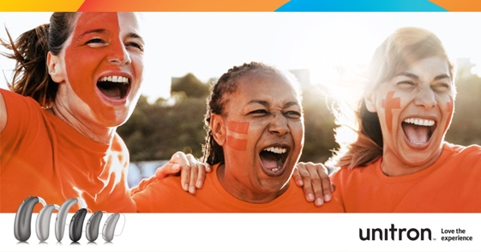  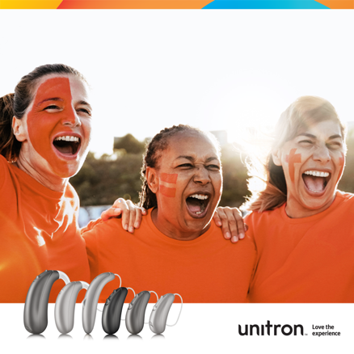
Facebook | Love sports? Love the experience with the brilliant sound performance of Vivante. Now until July 31, when you purchase a set of Vivante hearing aids, you get a free PartnerMic or TV Connector. Book an appointment to learn more: [URL]
Instagram | Experience all the excitement of your favorite sports with the brilliant sound performance of Vivante hearing aids. Now until July 31, when you purchase a set of Vivante hearing aids, you get a free PartnerMic or TV Connector. Contact us to book an appointment.

